Experiment no-20
RentRide – Vehicle Rental System
AIM:
To develop a vehicle rental website for searching vehicles and submitting booking requests.
PROCEDURE:
- Create an HTML file and design the webpage using HTML and CSS.
- Add user registration and login forms.
- Display vehicles with type, location, and rental price.
- Create a booking form with customer and rental details.
- Use JavaScript to display booking confirmation and test the website.
Sample Code:
<!DOCTYPE html>
<html>
<head>
<title>RentRide</title>
<style>
body { font-family: Arial; background: #e3f2fd; }
h1 { color: blue; }
input, select, button {
display: block;
margin: 10px;
padding: 8px;
}
</style>
</head>
<body>
<h1>RentRide - Vehicle Rental</h1>

<h2>Book a Vehicle</h2>
<form onsubmit="bookVehicle(event)">
<input id="name" placeholder="Customer Name" required>

<select id="vehicle">
<option>Car</option>
<option>SUV</option>
<option>Bike</option>
<option>Truck</option>
</select>

<input type="date" id="date" required>
<button type="submit">Book Now</button>
</form>

<p id="result"></p>

<script>
function bookVehicle(event) {
event.preventDefault();
let name = document.getElementById("name").value;
let vehicle = document.getElementById("vehicle").value;

document.getElementById("result").innerHTML =
"Booking successful for " + name +
" - " + vehicle;
}
</script>
</body>
</html>
Sample Output:
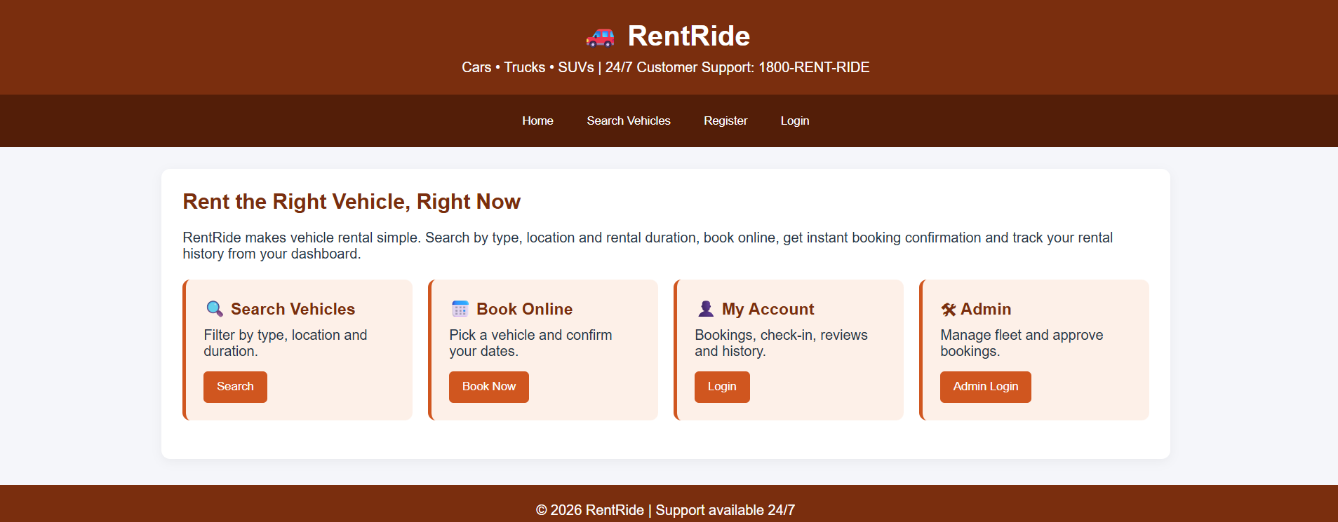
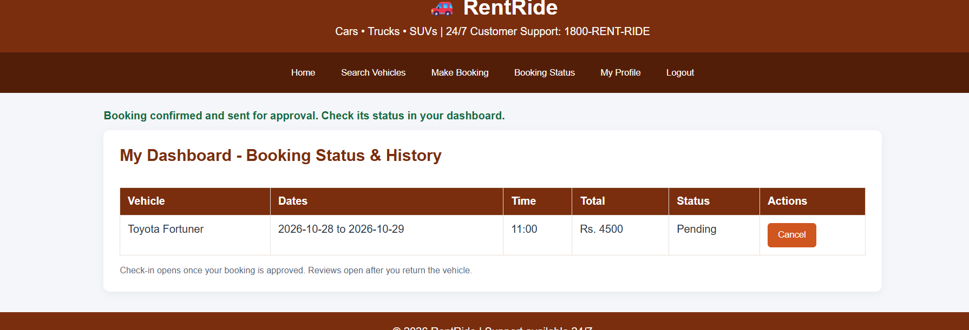

Result:
Thus, the RentRide website was created successfully to demonstrate vehicle selection and booking confirmation.

